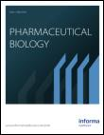**Pharmaceutical Biology**

**ISSN: 1388-0209 (Print) 1744-5116 (Online) Journal homepage:** [**https://www.tandfonline.com/loi/iphb20**](https://www.tandfonline.com/loi/iphb20)



**Hypoglycaemic Activity of Ibervillea sonorae Roots in Healthy and Diabetic Mice and Rats**

**F.J. Alarcon-Aguilar, A.E. Campos-Sepulveda, S. Xolalpa-Molina, E.**

**Hernandez-Galicia & R. Roman-Ramos**

**To cite this article:** F.J. Alarcon-Aguilar, A.E. Campos-Sepulveda, S. Xolalpa-Molina, E.Hernandez-Galicia & R. Roman-Ramos (2002) Hypoglycaemic Activity of Ibervillea sonorae Roots in Healthy and Diabetic Mice and Rats, Pharmaceutical Biology, 40:8, 570-575, DOI: [10.1076/](https://www.tandfonline.com/action/showCitFormats?doi=10.1076/phbi.40.8.570.14652) [phbi.40.8.570.14652](https://www.tandfonline.com/action/showCitFormats?doi=10.1076/phbi.40.8.570.14652)

**To link to this article:** <https://doi.org/10.1076/phbi.40.8.570.14652>



Published online: 29 Sep 2008.



[Submit your article to this journal](https://www.tandfonline.com/action/authorSubmission?journalCode=iphb20&show=instructions) 



Article views: 226



[View related articles](https://www.tandfonline.com/doi/mlt/10.1076/phbi.40.8.570.14652) 



[Citing articles: 7 View citing articles](https://www.tandfonline.com/doi/citedby/10.1076/phbi.40.8.570.14652#tabModule) 



Full Terms & Conditions of access and use can be found at

<https://www.tandfonline.com/action/journalInformation?journalCode=iphb20>

|  |  |
| --- | --- |
| Pharmaceutical Biology | 1388-0209/02/4008-570$16.00 |
| 2002, Vol. 40, No. 8, pp. 570–575 | © Swets & Zeitlinger |
|  |  |



**Hypoglycaemic Activity of *Ibervillea sonorae* Roots in Healthy and Diabetic Mice and Rats**



F.J. Alarcon-Aguilar1, A.E. Campos-Sepulveda2, S. Xolalpa-Molina3, E. Hernandez-Galicia1 and R. Roman-Ramos1

1División de Ciencias Biológicas y de la Salud, Universidad Autónoma Metropolitana Unidad Iztapalapa, México, D.F., Méxici; 2Departamento de Farmacología, Facultad de Medicina, Universidad Nacional Autónoma de México, Ciudad Universitaria, México D.F., México and 3Herbario IMSS-M, Centro Médico Nacional Siglo XXI, Subjefatura de Investigación, IMSS, México, D.F., México



**Abstract**

The acute effects of the freeze-dried decoction (traditional preparation) of *Ibervillea sonorae* Greene roots (Cucur-bitaceae) on blood glucose levels were investigated in fasting mice. The plant orally administrated to healthy mice did not cause a significant decrease of the blood glucose level. However, *I. sonorae* reduced the blood glucose of normal mice in a dose-dependent manner after intraperitoneal injec-tion (P < 0.05). Also, this extract significantly lowered the glycemia of mild alloxan-diabetic mice and rats, but did not in severe alloxan-diabetic rats, so it seems that this anti-diabetic plant needs the presence of insulin to show its hypoglycaemic activity. Chemical, pharmacological, and toxicological investigations of *I. sonorae* must continue to establish its use as an alternative in the control of diabetes mellitus. Furthermore, it is important to start programs leading to the preservation of this interesting resource.

**Keywords:** Hypoglycaemic plants, anti-diabetic plants,medicinal plants, *Ibervillea sonorae,* Cucurbitaceae.

**Introduction**

*Ibervillea sonorae* Greene (*Maximowiczia sonorae* S. Wats.),Cucurbitaceae, locally known as “wareke” or “guareke,” is a perennial dioecious plant which is distributed in the states of Sinaloa and Sonora in Mexico. Mayo, Opata, Seri, and Yaqui indigenous tribes have traditionally used this plant for skin ailments (Lopez & Hinojosa, 1988; Xolalpa-Molina, 1994). Ignacio Pfefferkorn, a Jesuit missionary who spent 11 years in the antique region of Sonora State, mentioned that “wareke” has been recommended for wound treatment ever



since the 18th century (Pfefferkorn, 1984). The decoction of the root of *I. sonorae* is one of the most highly used plant remedies in Mexico for the treatment of diabetes mellitus, a metabolic disorder that has one of the highest rates of inci-dence and mortality (Alpizar et al., 1998; ADA, 2000). However, until now, the anti-diabetic properties of this plant have not been investigated. The objective of this research was to study the hypoglycaemic activity of the traditional prepa-ration of *Ibervillea sonorae* roots in healthy and alloxan-diabetic mice and rats in order to validate the popular use of the plant in the control of diabetes mellitus.

**Materials and methods**

**Plant material**

Roots of *Ibervillea sonorae* were acquired from the Sonora Herbal Market at Mexico City. The identification was made, with the help of an expert in botany from HERBARIUM-IMSSM, using taxonomic rules (Herbarium IMSSM-Voucher Number 14, 184).

**Traditional preparation of *Ibervillea sonorae***

The plant was prepared as follows: ground dried roots (5 g) were steeped in boiling water (500 ml) for 15 min and then left to cool at room temperature. A similar decoction is the common form of administration used for diabetes mellitus. The decoction then was decanted and centrifuged. The supernatant was freeze-dried (yelding 1.2 g) and orally or intraperitoneally administered to experimental

Accepted: April 19, 2002

*Address correspondence to*: F.J. Alarcon-Aguilar, División de Ciencias Biológicas y de la Salud, Universsidad Autónoma Metropolitana

Unidad Iztapalapa., Apdo. P. 55-535.09340., México, D.F. México. Fax: +52 5804 4727; E-mail: aaasj2@prodigy.net.mx

|  |  |
| --- | --- |
| Hypoglycaemic activity of *Ibervillea sonorae* | 571 |

animals (it was dissolved in 4 ml/kg weight of isotonic saline solution, ISS).

**Experimental animals**

The experimental animals were male adult mice (CD1 strain) weighing from 25 to 35 g, and male adult rats (Wistar strain) weighing from 250 to 350 g. They were given free access to food and water. Experimental diabetes in mice and rats, sub-jected to previous fasting for 18 h, was induced by intraperi-toneal injection of alloxan (Rodriguez et al., 1975). The total dose of alloxan (450 mg/kg weight) was administered in 3 injections at intervals of 48 h (150 mg/kg body weight each time). Seven days after the last administration, the animals were fasted for 18 h and blood glucose levels were deter-mined. Diabetic rats were included in two experimental groups: (a) mild alloxan-diabetic rats, whose basal glycemia ranged between 200 to 349 mg/dl, and (b) severe alloxan-diabetic rats, whose basal glycemia was equal or higher than 350 mg/dl.

**Biological assays**

*Hypoglycemic effect of the freeze-dried decoction of* Ibervillea sonorae *roots in healthy mice*

Crossover trial using two administration routes

Intraperitoneal route (ip). Healthy mice were divided into two groups of six animals each (I-II). Group I served as control and received ISS. Group II received 300 mg/kg body weight of the freeze-dried decoction of *I. sonorae*. After 7 days, Group I received 300 mg/kg of *I. sonorae* and Group II served as control, receiving ISS.

Per os route (po). Two groups of six animals each (III and IV, respectively) were treated under the same conditions but in this case the freeze-dried decoction of *I. sonorae* was administered po (300 mg/kg). After seven days in a single test, Groups III and IV were also treated with ISS and *I.* *sonorae*, but in this case the administered dose of the plantwas 600 mg/kg.

*Hypoglycemic effect produced by the ip injection of different doses*

Healthy mice were divided to one group of 10 animals and five groups with 6 mice each (V-X). Groups V and VI served as controls, receiving ISS and tolbutamide (80 mg/kg), respectively. The other groups received different doses of the freeze-dried decoction of *I. sonorae* roots (150, 300, 600, and 850 mg/kg body weight).

*Hypoglycemic effect of the ip injection of freeze-dried decoction from* Ibervillea sonorae *roots in alloxan-diabetic mice*

Alloxan-diabetic mice were divided into four groups of 6 to 9 animals (XI–XIV). Group XI served as control and received

ISS; Group XII received tolbutamide as reference (80 mg/kg weight); Groups XIII and XIV received 300 and 500 mg/kg of the freeze-dried decoction of *I. sonorae* roots, respectively.

*Hypoglycemic effects of the ip injection of freeze-dried decoction from* Ibervillea sonorae *in mild and severe alloxan-diabetic rats*

Mild alloxan-diabetic rats were divided into two groups of 5 animals. Group 1 served as control and received ISS; Group 2 received freeze-dried decoction of *I. sonorae* roots (500 mg/kg weight).

Severe alloxan-diabetic rats were divided into three groups (3–5) with 5 animals: Group 3 served as control and received ISS; Group 4 received tolbutamide (80 mg/kg), and Group 5 freeze-dried decoction of *I. sonorae* roots (500 mg/kg body weight).

In all cases, the control substances, extracts, and fractions were dissolved in 4 ml/kg body weight of ISS. Blood samples were obtained from the tail vein of the animals at fasting (t = 0) and at 120, 240, and in some cases 360 min after the administration of test substances. Glycemia was quantita-tively determined with an Accutrend Sensor apparatus using reagent strips (Roche).

**Statistical analysis**

Results were expressed as mean ± S.E.M. The significance of the differences between the means of tests and control studies was established by Student’s *t*-test for independent samples with one tail. P-values < 0.05 were considered significant.

**Results**

Figure 1 illustrates the hypoglycemic effect produced by the ip injection of *I. sonorae* in healthy mice. The plant signifi-cantly reduced the blood glucose level at 240 min from 42.3

* 2.3 to 27.9 ± 2.5 mg/dl when it was compared to that of the control (P < 0.05). When *I. sonorae* was administered po at doses of 300 and 600 mg/kg to healthy mice, the glycemic levels remained without changes throughout the test (Tables 1 and 2). Figure 2 shows the results from the ip injection of different doses of *I. sonorae* to healthy mice (150, 300, 600 and 850 mg/kg). The doses of 150 and 300 mg/kg reduced significantly the glycemia at 120 and 240 min (P < 0.05). Doses of 600 and 850 mg/kg caused higher glycemic reduc-tions at 240 min. The blood glucose level reductions pro-duced by *I. sonorae* were more evident than those caused by tolbutamide (Fig. 2).

The hypoglycemic effect produced by the ip injection of 300 and 500 mg/kg of *I. sonorae* to mild alloxan-diabetic mice is shown in Figure 3. Both doses of *I. sonorae* signifi-cantly reduced glycemia at 240 and 360 min (P < 0.05). The dose of ip injected tolbutamide (80 mg/kg) also reduced glycemia. However, the effect was minor.

572 F.J. Alarcon-Aguilar et al.

|  |
| --- |
| GLYCEMIA mg/dl |

70

60

50

40

30

20

10

 *

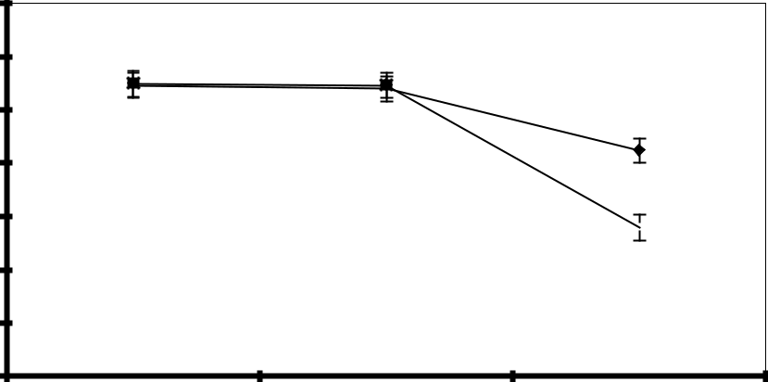

 ISS  *I. sonorae 300 mg/kg*

0

0 120 240

TIME (min)

*Figure 1.* Hypoglycemic effect produced by ip injection of the freeze-dried decoction of *Ibervillea sonorae* roots in healthy mice (n = 12).

Significantly different from control: * P < 0.05.

*Table 1.* Hypoglycemic effect produced by po administration of the freeze-dried decoction of *Ibervillea sonorae* roots in healthy mice (n=12).



|  |  |  |  |  |  |
| --- | --- | --- | --- | --- | --- |
|  |  | Glycemia mg/dl (Mean ± S.E.M.) | | |  |
|  |  |  |  |  |  |
| Study | DOSE | In fasting | 120 min | 240 min | 360 min |
|  |  |  |  |  |  |
| Control (ISS) | 4 ml/kg | 41.1 ± 2.3 | 43.1 ± 3.5 | 43.3 ± 4.3 | 40.0 ± 4.6 |
| *Ibervillea sonorae* | 300 mg/kg | 41.4 ± 1.5 | 43.7 ± 2.7 | 41.8 ± 4.0 | 36.5 ± 2.3 |
|  |  |  |  |  |  |

*Table 2.* Hypoglycemic effect produced by po injection of the freeze-dried decoction of *Ibervillea sonorae* roots in healthy mice (n=6).



|  |  |  |  |  |  |
| --- | --- | --- | --- | --- | --- |
|  |  | Glycemia mg/dl (Mean ± S.E.M.) | | |  |
|  |  |  |  |  |  |
| Study | DOSE | In fasting | 120 min | 240 min | 360 min |
|  |  |  |  |  |  |
| Control S.S.I. | 4 ml/kg | 46.0 ± 3.1 | 39.7 ± 2.5 | 44.2 ± 2.3 | 38.2 ± 1.7 |
| *Ibervillea sonorae* | 600 mg/kg | 42.1 ± 3.6 | 34.5 ± 2.7 | 35.8 ± 5.6 | 31.9 ± 2.2 |
|  |  |  |  |  |  |

*I. sonorae* also significantly reduced the blood glucoselevel of mild alloxan-diabetic rats at 240 and 360 min (Fig. 4). However, in severe alloxan-diabetic rats, the plant did not show a hypoglycemic effect (Table 3).

**Discussion**

Some indigenous tribes from Northwest Mexico have tradi-tionally used this plant to treat skin ailments by externally applying it on the affected areas (Lopez & Hinojosa, 1988; Xolalpa-Molina, 1994). However, since 12 years ago, the half-caste Mexican population has mostly used this plant to empirically control diabetes mellitus, but administering it orally.

The enteric administration route of *I. sonorae* started using either ground or encapsulated roots to eliminate the characteristic strong bitter taste of the plant. Furthermore, people that use *I. sonorae* for the treatment of diabetes have recently started to ingest its decoction (Xolalpa-Molina, 1994). It seems the change from external use to one that requires ingestion, derived from the strong bitter taste that, according to the popular logic, could be a method to dimi-nish “the sugar in blood,” one of the diabetes mellitus popular names in Mexico. Therefore, this change can be attributed to cultural rather than technical reasons.

The results show that when the plant is administered po even at doses as high as 600 mg/kg body weight there is no evidence of any acute hypoglycemic effect in fasted healthy mice. Since *I. sonorae* is normally taken orally by diabetic

|  |
| --- |
| GLYCEMIA mg/dl |

|  |  |
| --- | --- |
| Hypoglycaemic activity of *Ibervillea sonorae* | 573 |

70

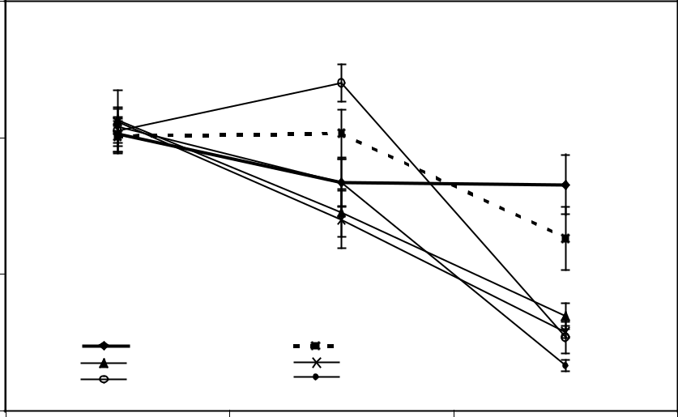

50

|  |  |  |  |
| --- | --- | --- | --- |
| 30 |  | * |  |
|  |  |  |
| *ISS* | *Tolbutamide* | * |  |
| * |  |
| *I. sonorae 150 mg/kg* | *I. sonorae 300 mg/kg* | * |  |
| *I. sonorae 600 mg/kg* | *I. sonorae 850 mg/kg* |  |
| 10 |  |  |  |
| 0 | 120 | 240 |  |
|  | TIME (min) |  |  |

*Figure 2.* Hypoglycemic effect produced the ip injection of different doses of freeze-dried decoction of *Ibervillea sonorae* roots in healthymice. Significantly different from control: * P < 0.05.

|  |  |  |  |  |  |
| --- | --- | --- | --- | --- | --- |
|  | 300 |  |  |  |  |
|  |  | *ISS* |  | *Tolbutamide 80 mg/kg* |  |
|  | 250 | *I. sonorae 300 mg/kg* |  | *I. sonorae 500 mg/kg* |  |
|  |  |  |  |  |
| mg/dl | 200 |  |  |  |  |
|  |  |  |  |  |
| GLYCEMIA | 150 |  |  |  |  |
| 100 |  |  | * |  |
|  |  |  |  |
|  |  |  |  |  |
|  | 50 |  |  | * |  |
|  |  |  |  |  |
|  | 0 |  |  | * |  |
|  |  |  |  |  |
|  | 0 | 120 | 240 | 360 |  |

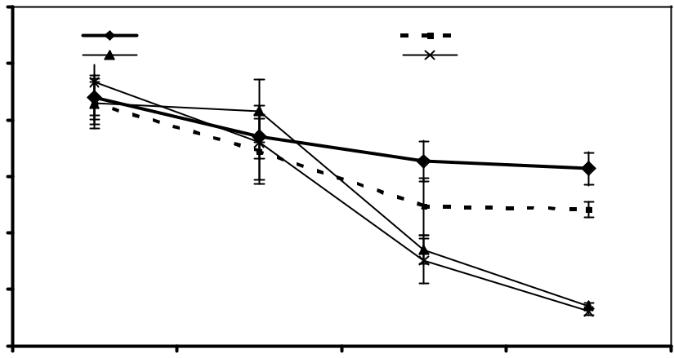

TIME (min)

*Figure 3.* Hypoglycemic effect of the ip injection of freeze-dried decoction from *Ibervillea sonorae* roots in alloxan-diabetic mice.

Significantly different from control: * P < 0.05.

patients, it may be the observed hypoglycemic effect in them is produced because the plant needs to be stored in the body. Therefore, it is necessary to start chronic studies to observe the oral effect.

The results show that when *I. sonorae* is injected by the ip route in healthy mice, it produces a hypoglycemic effect. It is possible to obtain more complete absorption of the active substances this way, making it easier to detect hypoglycaemic activity. Consequently, the ip route was selected to continue this investigation.

*I. sonorae* at doses of 150 and 300 mg/kg administered ip,significantly reduced the glycemia of healthy mice at 120 and

240 min, while those of 600 and 850 mg/kg responded at 240 min. However, it is important to note that the plant shows a dose-dependent hypoglycemic effect at 240 min.

With regard to the hypoglycemic effect in alloxan-diabetic mice and rats, the results indicate that *I. sonorae* reduced the glycemia in mild-diabetic, but did not in severe diabetic animals. To prove that the hypoglycemic activity of *I. sonorae* roots requires the presence of functional pancreatic beta cells, it is necessary to observe an improvement in plasma insulin levels. Although this improvement did not happen, the fasting glycemia in severe alloxan-diabetic rats was higher than 350 mg/dl, indicating greater damage to the insulin

574 F.J. Alarcon-Aguilar et al.

|  |  |  |  |  |  |
| --- | --- | --- | --- | --- | --- |
|  | 300 |  |  |  |  |
|  | 250 |  |  |  |  |
| mg/dl | 200 |  |  |  |  |
|  |  |  |  |  |
| GLYCEMIA | 150 |  |  |  |  |
| 100 |  |  |  |  |
|  |  |  |  |  |
|  | 50 |  |  | * |  |
|  | ISS | *I. sonorae 500 mg/kg* |  |  |  |
|  | 0 |  |  |  |  |
|  | 0 | 120 | 240 | 360 |  |

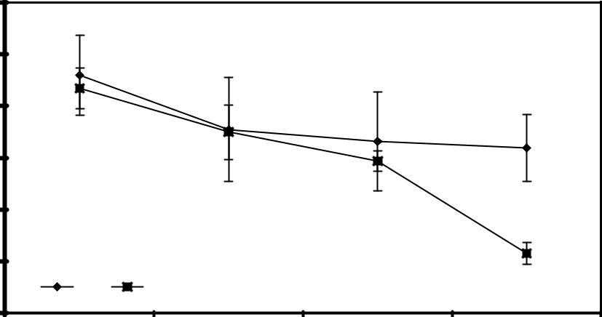

TIME (min)

*Figure 4.* Hypoglycemic effect of the ip injection of freeze-dried decoction from *Ibervillea sonorae* in mild alloxan-diabetic rats (n = 5).

Significantly different from control: * P < 0.05.

*Table 3.* Hypoglycaemic effects of the ip injection of freeze-dried decoction from *Ibervillea sonorae* in severe alloxan-diabetic rats (n=5).



|  |  |  |  |  |  |  |  |  |  |  |  |  |
| --- | --- | --- | --- | --- | --- | --- | --- | --- | --- | --- | --- | --- |
|  |  |  |  | Glycemia mg/dl (Mean ± S.E.M.) | | | | | |  |  |  |
|  |  |  |  | | |  | |  | | |  | |
| Study | DOSE |  | In fasting | | | 120 min | | 240 min | | | 360 min | |
|  |  |  | |  | |  |  |  |  |  |  |  |
| Control (ISS) | 4 ml/kg | 367.5 | | ± 14.2 | | 368.0 | ± 14.8 | 366.5 | ± | 7.6 | 365.3 | ± 11.4 |
| Tolbutamide | 80 mg/kg | 365.0 | | ± | 9.5 | 396.0 | ± 6.9 | 362.0 | ± | 6.4 | 355.5 | ± 4.7 |
| *Ibervillea* | 500 mg/kg | 376.5 | | ± | 5.3 | 394.0 | ± 16.5 | 372.0 | ± 19.1 | | 379.0 | ± 11.6 |
| *sonorae* |  |  |  |  |  |  |  |  |  |  |  |  |
|  |  |  |  |  |  |  |  |  |  |  |  |  |

secreting cells of the pancreas in these animals than to those with mild alloxan diabetic animals (fasting glycemia between 200–349 mg/dl). The presence of insulin in mild diabetic animals and its absence in severe diabetic animals was indi-rectly demonstrated by means of the tolbutamide effects. This hypoglycaemic agent, whose principal mechanism of action is to induce the synthesis and secretion of insulin, caused a hypoglycemic effect in mild diabetic mice and rats, but did not in severe diabetic rats.

Hence, this investigation confirms the results obtained with other anti-diabetic plants whose traditional preparations have been evaluated (*Psacalium decompositum*, *P. peltatum*, *Cucurbita ficifolia* and *Lepechinia caulescens*). All of themsuggest that the endogenous insulin is necessary for hypo-glycaemic activity, although extra-pancreatic activity cannot yet be excluded (Roman-Ramos et al., 1992; Alarcon-Aguilar et al., 2000).

*Ibervillea sonorae* belongs to the Cucurbitaceae family,and although not many Cucurbitaceae plants are used as anti-diabetic remedies, some genera have been mentioned by Marles and Farnsworth (1995): *Benincasa*, *Bryonia*, *Citrullus*, *Coccinia*, *Cucumis*, *Cucurbita*, *Lagenaria*, *Luffa*, *Melothria*, *Momordica*, and *Trichosanthes*. This is the first

investigation with an anti-diabetic plant that belongs to the *Ibervillea* genus.

Thirty species were included in the genera mentioned before, twelve that have shown hypoglycaemic activity in clinical and experimental trials. However, excluding *Coc-cinia indica* Wight and Arn., *Trichosanthes dioica* Roxb., andsome edible plants (e.g., *Cucumis sativus* Linn. and *Cucur-bita ficifolia* Bouché), the majority of the other species seemhave some toxic effect when they were orally administered (Marles & Farnsworth, 1995; Roman-Ramos et al., 1995). In this research, the part tested from *I. sonorae* was the root. The hypoglycemic effects of the roots from *Bryonia alba* Linn., *B. dioica* Jacq., *Coccinia cordifolia* (L.) Cogn., *C. indica*, *Trichosanthes dioica*, and *T. kirilowii* Maxim.have been experimentally evaluated. Only the roots of *C.* *cordifolia* and *T. dioica* did not show toxic effects (Marles& Farnsworth, 1995).

Although these results seem to predict toxicity in *I.* *sonorae*, when it was intraperitoneally injected at doses ashigh as 850 mg/kg body weight, or when it was orally admin-istered at doses at high as 2000 mg/kg, no signs of toxicity were observed in healthy mice. Therefore, in order to achieve its lethal effect, it is necessary to increase these doses*.*

|  |  |
| --- | --- |
| Hypoglycaemic activity of *Ibervillea sonorae* | 575 |

Some active constituents from Cucurbitaceae species have been isolated, such as: trihydroxyoctadecadienoic acid from *Bryonia alba*, pectin and a quaternary alkaloid from *Coc-cinia indica*, and charantin from *Momordica foetida* Schu-mach and Thonn. Charantin was isolated from *Momordica* *charantia* Linn., the most widely used medicinal plant in thecontrol of diabetes mellitus, and one of the most studied anti-diabetic plants as well (Karunanayake et al., 1984, 1990; Welihinda & Karunanayake, 1986; Ali et al., 1993; Tennekoon et al., 1994; Marles & Farnsworth, 1995; De Smet, 1997; Perez et al., 1998).

It is very important to consider the impact of the depre-dation of this wild plant species caused by human beings. The reproductive process of *Ibervillea sonorae* is decreasing because the root is the part of the plant used for the empiri-cal treatment of diabetes. Although the quantity of plant material extracted is unknown, it is important to start pro-grams leading to the preservation of this interesting resource. It is also a priority to start the toxicological studies of *I.* *sonorae*, as well as the chemical and pharmacological trialsaimed to isolate and characterize the active constituent. The plant of *I. sonorae* exists in two reproductive forms (male and female). Although people in Mexico traditionally use a mixture of the male and female plants, it is necessary to determine if both forms cause the same hypoglycemic effect.

The present investigation shows that *Ibervillea sonorae* roots reduce the blood glucose levels in healthy mice and mild alloxan-diabetic mice and rats, but do not reduce hyper-glycemia in severe alloxan-diabetic rats. In conjunction with previous toxicological studies, these results validate the use of *I. sonorae* in the treatment of type 2 diabetes.

**References**

Alarcon-Aguilar FJ, Jimenez-Estrada M, Reyes-Chilpa R, Roman-Ramos R (2000): Hypoglycaemic effect of extracts and fractions from *Psacalium decompositum* in healthy and alloxan-diabetic mice. *J Ethnopharmacol 72*: 21–27.

Ali L, Azad Khan AK, Rouf Mamun MI, Mosihuzzaman M, Nahar N, Nur-e-Alam M, Rokeya B (1993): Studies on hypoglycemic effects of fruit pulp, seed, and whole plant of *Momordica charantia* on normal and diabetic model rats. *Planta Med 59*: 408–412.

Alpizar-Salazar M, Sotomayor-Gallardo A, Castro-Ramos MA, Zarate-Aguilar A, Madrazo-Navarro M (1998): Diabetes

mellitus, prioridad institucional. *Salud Comunitaria 2*:

31–35.

American Diabetes Association (2000): Screening for type 2 diabetes (Position Statement). *Diabetes Care 23* (Suppl. 1): 20–23.

De Smet PAGM (1997): The role of plant-derived drugs and

herbal medicines in healthcare. *Drugs 54*: 801–840.

Karunanayake EH, Welihinda J, Sirimanne SR, Gowri Sinnadorai (1984): Oral hypoglycaemic activity of some medicinal plants of Sri Lanka. *J Ethnopharmacol 11*: 223– 231.

Karunanayake EH, Jeevathayaparan S, Tennekoon KH (1990): Effect of *Momordica charantia* fruit juice on streptozotocin induced diabetes in rats. *J Ethnopharmacol 30*: 199–204.

Lopez R, Hinojosa A (1988): *Catálogo de plantas medicinales* *sonorenses*. Universidad de Sonora, Hermosillo Son,México. 133 p.

Marles RJ, Farnsworth NR (1995): Antidiabetic plants and their

active constituents. *Phytomedicine 2*: 137–189.

Perez GRM, Zavala SMA, Perez GS, Perez GC (1998): Anti-diabetic effect of compounds isolated from plants. *Phytomedicine 5*: 55–75.

Pfefferkorn I (1984): *Descripción de la provincia de Sonora*. Libro Primero. Gobierno del Estado de Sonora, Her-mosillo, Son, México.

Rodriguez H, Perez RM, Muñoz H, Perez C, Miranda R (1975): Inducción de diabetes en ratón por medio de aloxana. *Acta* *Medica XI*: 33–36.

Roman-Ramos R, Lara-Lemus A, Alarcon-Aguilar F, Flores-Saenz JL (1992): Hypoglycaemic activity of some antidia-betic plants*. Arch Med Res 23*: 105–109.

Roman-Ramos R, Flores-Saenz JL, Alarcon-Aguilar F (1995): Anti-hyperglycemic effect of some edible plants. *J* *Ethnopharmacol 48*: 25–32.

Tennekoon KH, Jeevathayaparan S, Angunawala P, Karunanayake EH, Jayasinghe KSA (1994): Effect of *Momordica charantia* on key hepatic enzymes. *J Ethnopharmacol 44*: 93–97.

Welihinda J, Karunanayake EH (1986): Extra-pancreatic effects of *Momordica charantia* in rats. *J Ethnopharmacol 17*: 247–255.

Xolalpa-Molina S (1994): Flora Medicinal Mayo de la región de El Fuerte y Choix, Sinaloa. In: Instituto Nacional Indigenista, ed., *Biblioteca de la Medicina Tradicional* *Mexicana. Flora Medicinal Indígena de México*. Tomo I,México, pp. 363–411.